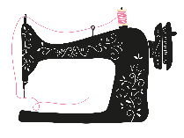
Tuning My Heart Quilts
Under the Stars
Block of the Week Quilt
by Debra Davis

____________________________________________________________________________
Block 1 – Eight Hands Around
Fabric Needed for Red and White Version: 2 greys, 2 medium red, 1 dark red, and white

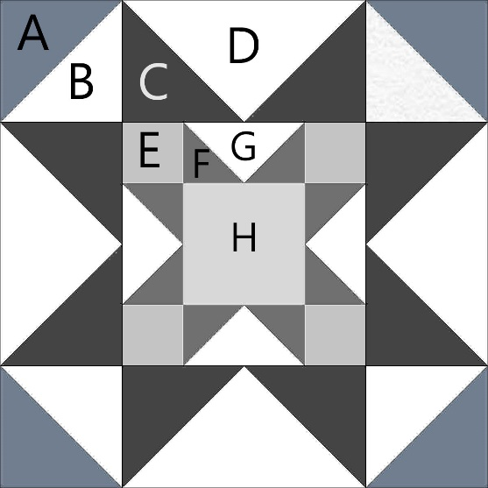
Cutting Directions:
A- (cut 2) 5 1/8” x 5 1/8” medium Red # 1
B- (cut 2) 5 1/8” x 5 1/8” white
C- (cut 4) 5 1/8” x 5 1/8” Dark Red
D- (cut 1) 9 ½” x 9 ½” white
E- (cut 4) 2 ½” x 2 ½” Grey #1
F- (cut 4) 3 1/8” x 3 1/8” medium Red # 2
G-(cut 1) 5 ½” x 5 ½” white
H- (cut 1) 4 ½” x 4 ½” Grey #2

Fabric Needed for Color Version: 1 light, 3 medium, 1 dark, and white
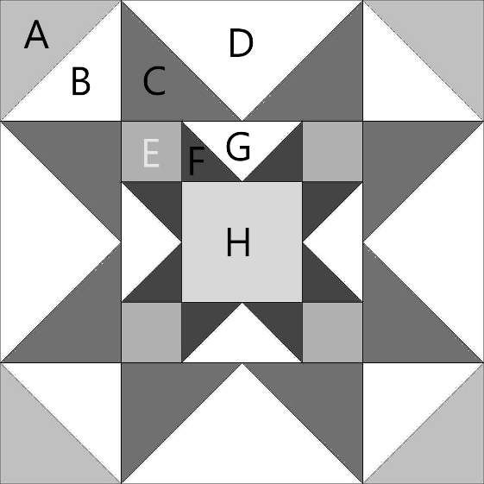
Cutting Directions:
A- (cut 2) 5 1/8” x 5 1/8” medium #1
B- (cut 2) 5 1/8” x 5 1/8” white
C- (cut 4) 5 1/8” x 5 1/8” medium # 2
D- (cut 1) 9 ½” x 9 ½” white
E- (cut 4) 2 ½” x 2 ½” medium #3
F- (cut 4) 3 1/8” x 3 1/8” dark
G-(cut 1) 5 ½” x 5 ½” white
H- (cut 1) 4 ½” x 4 ½” light

To Make the Block:
Step 1: Using A and B squares make four Half-square triangle units. (HST’s)
On the back of the B squares draw a line down the middle. Place right sides together with A square. Sew ¼ inch from each side of the line.
Cut apart on line and press towards darker side.
Trim to 4 ½” squares.

Step 2: Using the C and D squares make four Flying Geese units.
Place two C squares right sides together on the D square. Draw a line down the middle. Sew ¼ inch from each side of the line. Cut apart on the line and press towards the small triangles. Place another C square on top of unit and draw a line down the middle. Sew ¼ inch from each side of the drawn line, cut apart and press towards the small triangles. Trim Flying Geese units to 4 ½” x 8 ½”

Step 3:
Repeat step 2 using the F and G squares.
Trim these units to 2 ½” x 4 ½”

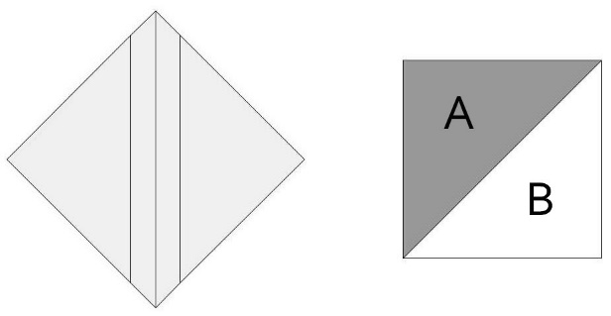

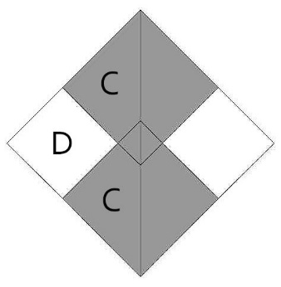

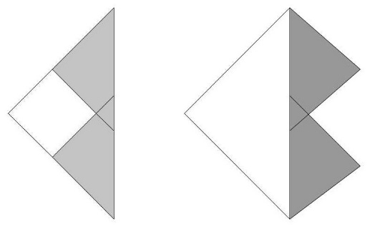

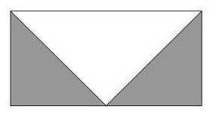
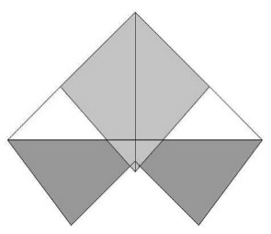

Step 4:
Assemble the center 9-patch square.
Press top and bottom rows toward E.
Press middle row towards H.
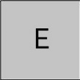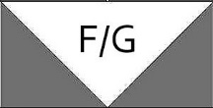

Step 5:
Assemble Block. Press top and bottom rows towards HST’s. Press middle row towards center square.

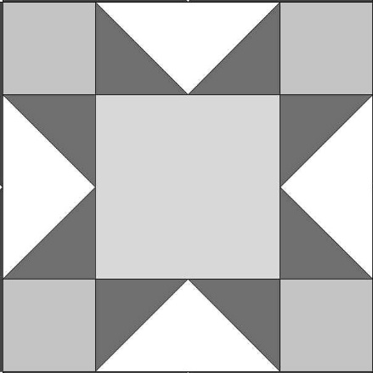

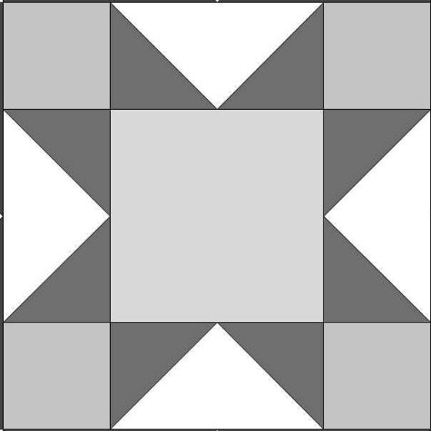

A WORD ABOUT COPYRIGHT: While these patterns are free I do ask that they not be shared in anyway. Please direct people to come and download them from my website. In this way you are showing support for what I am providing for you here. As for the quilts you make-you can do whatever you like with them, alter them, give them away, enter them in a show, snuggle up under them, have a picnic on them, even sell a couple of them, (please contact me if you intend to sell more than that at tuningmyheart@gmail.com) -In essence I would just like to be given credit as the designer of the pattern.

